**EXPERIMENT -4**

**EXP NO 4:** CREATE A SIMPLE CLOUD SOFTWARE APPLICATION FOR CAR BOOKING RESERVATION SYSTEM USING ANY CLOUD SERVICE PROVIDER TO DEMONSTRATE SAAS.

**DATE: 27/09/25**

**AIM**: To Create a simple cloud software application for Car Booking Reservation System using any Cloud Service Provider to demonstrate SaaS.

**PROCEDURE:**

Step1: Go To Zoho.Com.

Step 2: Log Into the Zoho.Com.

Step 3: Select One Application Step.

Step4: Enter Application Name as Car Booking Reservation System.

Step 5: Created New Application as Car Booking Reservation System.

Step 6: Select One Form

Step 7: The Software Has Been Created.

Form 1: User registration form.

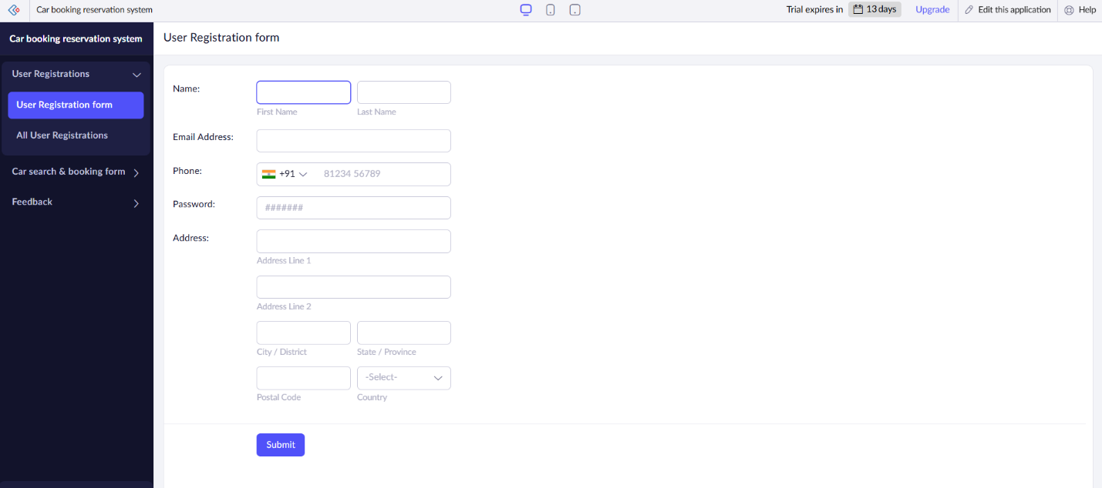

Form 2: car search & booking form.

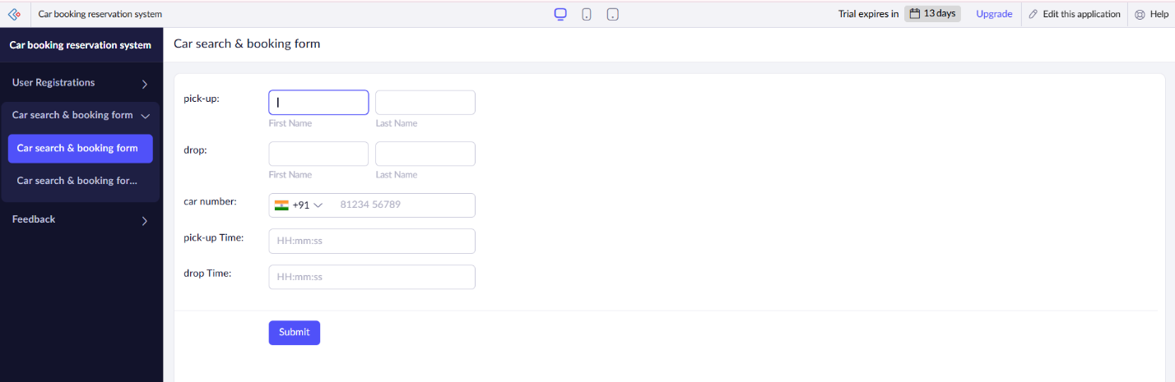

Form 3: Feedback.

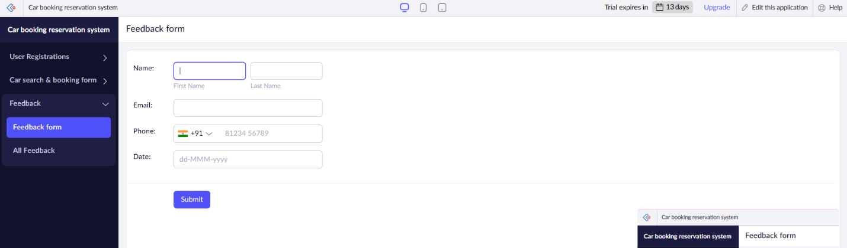

Form 1: User registration form.

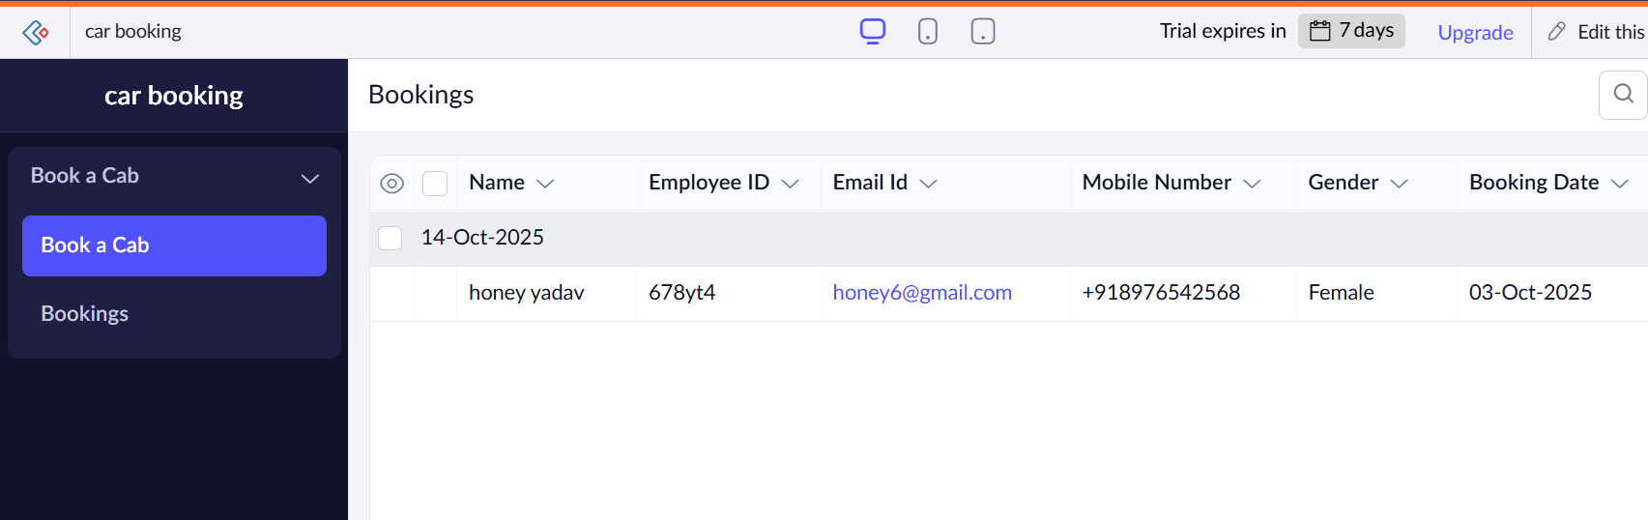

Form 2: car search & booking form.

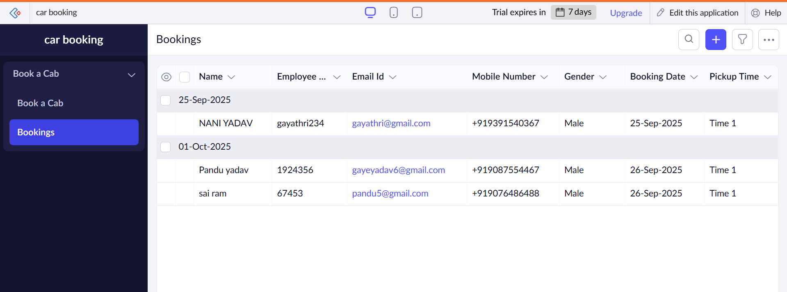

Form 3: Feedback.

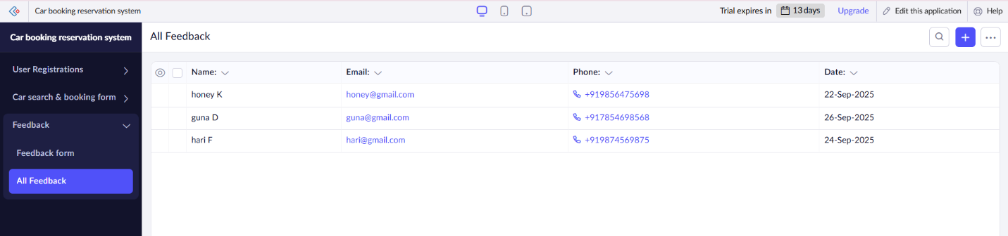

Result:

A cloud‑hosted SaaS car‑booking system where users can search available cars by location & time, book & pay online, owners manage their fleet & availability through a dashboard, and the system scales automatically with usage.